1973
AP Biology Examination

Directions: Each of the questions or incomplete statements below is followed by five suggested answers or completions. Select the .one that is best in each case and then fill in the corresponding oval on the answer sheet.

- The principal components of viruses are
(A) protein and lipid
(B) DNA and RNA
(C) RNA and lipid
(D) DNA and carbohydrate
(E) protein and nucleic acid

- The primary producer in a food chain is usually
(A) xerophytic
(B) heterotrophic
(C) chemosynthetic
(D) saprophytic
(E) autotrophic

- In his experiments with garden peas, Mendel demonstrated that
(A) peas have seven pairs of chromosomes
(B) each allele he studied was located on a different chromosome
(C) the same principles of genetics apply to peas and to man
(D) recessive alleles retain their fundamental natures even when unexpressed
(E) hybridization is essential for propagation of peas to occur

- Under optimal conditions. the number of bacterial cells increases most rapidly as a result of
(A) asexual reproduction
(B) sexual reproduction
(C) endospore germination
(D) budding
(E) cyst formation

- Some species of land plants are capable of surviving unfavorable environmental conditions by all of the following adaptations EXCEPT the
(A) storage of foods in various parts of a plant
(B) production of seeds
(C) increased production of new kinds of photosynthetic pigments
(D) loss of leaves
(E) formation of buds

- Which of the following is the most important role of bacteria and fungi in a community of living organisms?
(A) Fixation of nitrogen
(B) Synthesis of antibiotics
(C) Decomposition of organic materials
(D) Causation of disease
(E) Alcoholic fermentation

- One of the usual characteristics of sewage-pollute waters is
(A) a low turbidity
(B) a low oxygen content
(C) a wide variety of aquatic wildlife
(D) the absence of gas-forming bacteria
(E) a relatively high temperature

- The first man to present convincing evidence that the blood circulates rather than merely surging back and forth was
(A) Darwin
(B) Redi
(C) Pasteur
(D) Harvey
(E) Vesalius

- The most critical characteristic used by taxonomists to determine whether tWo animals are mem bers of the same species is the
(A) similarity in embryonic development
(B) similarity in structure
(C) similarity in behavior patterns
(D) distribution into a definite geographical area
(E) ability to interbreed freely

- In a transfusion of blood which of the following should the recipient have?
(A) Antibodies in his plasma against the type of antigen in the donor's white cells
(B) The same antibodies as the donor but different antigens
(C) Type 0 blood if that of the donor is not known
(D) The same antigens as the donor
(E) Antibodies in his plasma against the type of antigen in the donor's red cells

- All of the following generalizations are consistent with the physical and chemical factors found in a food chain EXCEPT:
(A) The secondary consumers are usually larger in size than the primary consumers.
(B) The biomass of a food chain is greatest at the producer level.
(C) An increase in the number of organisms occurs in successive links of the food chain.
(D) The amount of available energy decreases in successive links of the food chain.
(E) The available energy in a food chain is limited by the total amount of photosynthesis.

- The application of a paste containing IAA (auxin) in low concentration near the tip of the stem of a young pea seedling growing in diffuse light would be expected to result in the
(A) inhibition of elongation of the stem
(B) inhibition of elongation of the root
(C) bending of the stem toward the side on which the paste-had been applied
(D) bending of the stem away from the side on which the paste had been applied
(E) stimulation of bud development

- There is good evidence of linkage when
(A) genes of two different loci segregate independently
(B) genes of two different loci do not segregate independently
(C) a gene is invariably associated with a specific characteristic
(D) two genes invariably work together to control the expression of a single characteristic
(E) two genes are located together in a single gamete

- The lysosome has a high content of
(A) enzymes
(B) cytochromes
(C) DNA
(D) chlorophyll
(E) ribosomes

- The evolution of flowering plants involved all of the following trends EXCEPT
(A) an increase in the relative size of the gametophyte generation
(B) an increase in the complexity of the sporophyte generation
(C) increased dependence of the gametophyte generation on the sporophyte generation
(D) the development of vascular tissue
(E) the loss of sperm flagella

- In a diploid organism with the genotype AaBBCCDDEE, how many genetically distinct kinds of gametes would be produced?
(A) 2
(B) 4
(C) 8
(D) 16
(E) 32

- If a particular recessive allele of a gene pair in a population exists at a frequency of 0.4, and the other allele shows complete dominance, the dominant phenotype is seen in what percentage of the individuals in this population?
16. In a diploid organism with the genotype AaBBCCDDEE, how many genetically distinct kinds of gametes would be produced?
(A) 2 (B) 4 (C) 8 (D) 16 (E) 32
17. If a particular recessive allele of a gene pair in a population exists at a frequency of 0.4, and the
other allele shows complete dominance, the dominant phenotype is seen in what percentage of the individuals in this population?
(A) 4% (B) 16% (C) 3~ (D) ~% (E) 84%
18. The cyclical natUre of the estrous cycle in mammals is maintained by a feed- back system betWeen the (A) ovary, anterior pitUitary, and hypothalamus (B) ovary, placenta, and uterus
(C) placenta, anterior pitUitary, and oviducts
(D) ovary, posterior pitUitary, and uterus
(E) ovary, the lining of the uterus, and hypothalamus
19. In general. birds differ from mammals in that birds
(A) are homoiotherms
(B) have four-chambered hearts
(C) have.hepatic portal veins
(D) develop without an amnion
(E) excrete waste nitrogen as uric acid
20. Which of the following would NOT increase the rate of transpiration in an angiosperm?
(A) Morning sunshine
(B) An increase in temperatUre from 200C to
300C
(C) An increase in relative humidity
(D) An increase in the water content of the soil (E) An increase in air velocity
21. Which of the following organisms is saprophytic, composed of hyphae. and produces basidiospores?
(A) Slime mold (B) Bread mold (C) M~hroom
(D) Penicillium (E) Yeast
22. Which of the following is NOT associated with nuclear division and cell division in animals? (A) Formation of spindles
(B) Duplication of chromosomes (C) Formation of cell plates
(D) Constriction of the dividing cells (E) Separation of chromosomes
16. In a diploid organism with the genotype AaBBCCDDEE, how many genetically distinct kinds of gametes would be produced?
(A) 2 (B) 4 (C) 8 (D) 16 (E) 32
17. If a particular recessive allele of a gene pair in a population exists at a frequency of 0.4, and the
other allele shows complete dominance, the dominant phenotype is seen in what percentage of the individuals in this population?
(A) 4% (B) 16% (C) 3~ (D) ~% (E) 84%
18. The cyclical natUre of the estrous cycle in mammals is maintained by a feed- back system betWeen the (A) ovary, anterior pitUitary, and hypothalamus (B) ovary, placenta, and uterus
(C) placenta, anterior pitUitary, and oviducts
(D) ovary, posterior pitUitary, and uterus
(E) ovary, the lining of the uterus, and hypothalamus
19. In general. birds differ from mammals in that birds
(A) are homoiotherms
(B) have four-chambered hearts
(C) have.hepatic portal veins
(D) develop without an amnion
(E) excrete waste nitrogen as uric acid
20. Which of the following would NOT increase the rate of transpiration in an angiosperm?
(A) Morning sunshine
(B) An increase in temperatUre from 200C to
300C
(C) An increase in relative humidity
(D) An increase in the water content of the soil (E) An increase in air velocity
21. Which of the following organisms is saprophytic, composed of hyphae. and produces basidiospores?
(A) Slime mold (B) Bread mold (C) M~hroom
(D) Penicillium (E) Yeast
22. Which of the following is NOT associated with nuclear division and cell division in animals? (A) Formation of spindles
(B) Duplication of chromosomes (C) Formation of cell plates
(D) Constriction of the dividing cells (E) Separation of chromosomes
16. In a diploid organism with the genotype AaBBCCDDEE, how many genetically distinct kinds of gametes would be produced?
(A) 2 (B) 4 (C) 8 (D) 16 (E) 32
17. If a particular recessive allele of a gene pair in a population exists at a frequency of 0.4, and the
other allele shows complete dominance, the dominant phenotype is seen in what percentage of the individuals in this population?
(A) 4% (B) 16% (C) 3~ (D) ~% (E) 84%
18. The cyclical natUre of the estrous cycle in mammals is maintained by a feed- back system betWeen the (A) ovary, anterior pitUitary, and hypothalamus (B) ovary, placenta, and uterus
(C) placenta, anterior pitUitary, and oviducts
(D) ovary, posterior pitUitary, and uterus
(E) ovary, the lining of the uterus, and hypothalamus
19. In general. birds differ from mammals in that birds
(A) are homoiotherms
(B) have four-chambered hearts
(C) have.hepatic portal veins
(D) develop without an amnion
(E) excrete waste nitrogen as uric acid
20. Which of the following would NOT increase the rate of transpiration in an angiosperm?
(A) Morning sunshine
(B) An increase in temperatUre from 200C to
300C
(C) An increase in relative humidity
(D) An increase in the water content of the soil (E) An increase in air velocity
21. Which of the following organisms is saprophytic, composed of hyphae. and produces basidiospores?
(A) Slime mold (B) Bread mold (C) M~hroom
(D) Penicillium (E) Yeast
22. Which of the following is NOT associated with nuclear division and cell division in animals? (A) Formation of spindles
(B) Duplication of chromosomes (C) Formation of cell plates
(D) Constriction of the dividing cells (E) Separation of chromosomes
16. In a diploid organism with the genotype AaBBCCDDEE, how many genetically distinct kinds of gametes would be produced?
(A) 2 (B) 4 (C) 8 (D) 16 (E) 32
17. If a particular recessive allele of a gene pair in a population exists at a frequency of 0.4, and the
other allele shows complete dominance, the dominant phenotype is seen in what percentage of the individuals in this population?
(A) 4% (B) 16% (C) 3~ (D) ~% (E) 84%
18. The cyclical natUre of the estrous cycle in mammals is maintained by a feed- back system betWeen the (A) ovary, anterior pitUitary, and hypothalamus (B) ovary, placenta, and uterus
(C) placenta, anterior pitUitary, and oviducts
(D) ovary, posterior pitUitary, and uterus
(E) ovary, the lining of the uterus, and hypothalamus
19. In general. birds differ from mammals in that birds
(A) are homoiotherms
(B) have four-chambered hearts
(C) have.hepatic portal veins
(D) develop without an amnion
(E) excrete waste nitrogen as uric acid
20. Which of the following would NOT increase the rate of transpiration in an angiosperm?
(A) Morning sunshine
(B) An increase in temperatUre from 200C to
300C
(C) An increase in relative humidity
(D) An increase in the water content of the soil (E) An increase in air velocity
21. Which of the following organisms is saprophytic, composed of hyphae. and produces basidiospores?
(A) Slime mold (B) Bread mold (C) M~hroom
(D) Penicillium (E) Yeast
22. Which of the following is NOT associated with nuclear division and cell division in animals? (A) Formation of spindles
(B) Duplication of chromosomes (C) Formation of cell plates
(D) Constriction of the dividing cells (E) Separation of chromosomes
16. In a diploid organism with the genotype AaBBCCDDEE, how many genetically distinct kinds of gametes would be produced?
(A) 2 (B) 4 (C) 8 (D) 16 (E) 32
17. If a particular recessive allele of a gene pair in a population exists at a frequency of 0.4, and the
other allele shows complete dominance, the dominant phenotype is seen in what percentage of the individuals in this population?
(A) 4% (B) 16% (C) 3~ (D) ~% (E) 84%
18. The cyclical natUre of the estrous cycle in mammals is maintained by a feed- back system betWeen the (A) ovary, anterior pitUitary, and hypothalamus (B) ovary, placenta, and uterus
(C) placenta, anterior pitUitary, and oviducts
(D) ovary, posterior pitUitary, and uterus
(E) ovary, the lining of the uterus, and hypothalamus
19. In general. birds differ from mammals in that birds
(A) are homoiotherms
(B) have four-chambered hearts
(C) have.hepatic portal veins
(D) develop without an amnion
(E) excrete waste nitrogen as uric acid
17. If a particular recessive allele of a gene pair in a population exists at a frequency of 0.4, and the
other allele shows complete dominance, the dominant phenotype is seen in what percentage of the individuals in this population?
(A) 4% (B) 16% (C) 3~ (D) ~% (E) 84%
18. The cyclical natUre of the estrous cycle in mammals is maintained by a feed- back system betWeen the (A) ovary, anterior pitUitary, and hypothalamus (B) ovary, placenta, and uterus
(C) placenta, anterior pitUitary, and oviducts
(D) ovary, posterior pitUitary, and uterus
(E) ovary, the lining of the uterus, and hypothalamus
17. If a particular recessive allele of a gene pair in a population exists at a frequency of 0.4, and the
other allele shows complete dominance, the dominant phenotype is seen in what percentage of the individuals in this population?
(A) 4% (B) 16% (C) 3~ (D) ~% (E) 84%
18. The cyclical natUre of the estrous cycle in mammals is maintained by a feed- back system betWeen the (A) ovary, anterior pitUitary, and hypothalamus (B) ovary, placenta, and uterus
(C) placenta, anterior pitUitary, and oviducts
(D) ovary, posterior pitUitary, and uterus
(E) ovary, the lining of the uterus, and hypothalamus
(A) 4%
(B) 16%
(C) 36
(D) 64%
(E) 84%

- The cyclical nature of the estrous cycle in mammals is maintained by a feed- back system between the
(A) ovary, anterior pituitary, and hypothalamus
(B) ovary, placenta, and uterus
(C) placenta, anterior pituitary, and oviducts
(D) ovary, posterior pituitary, and uterus
(E) ovary, the lining of the uterus, and hypothalamus

- In general, birds differ from mammals in that birds
(A) are homeotherms
(B) have four-chambered hearts
(C) have hepatic portal veins
(D) develop without an amnion
(E) excrete waste nitrogen as uric acid

- Which of the following would NOT increase the rate of transpiration in an angiosperm?
(A) Morning sunshine
(B) An increase in temperature from 200°C to 300°C
(C) An increase in relative humidity
(D) An increase in the water content of the soil
(E) An increase in air velocity

- Which of the following organisms is saprophytic, composed of hyphae. and produces basidiospores?
(A) Slime mold
(B) Bread mold
(C) Mushroom
(D) Penicillium
(E) Yeast

- Which of the following is NOT associated with nuclear division and cell division in animals?
(A) Formation of spindles
(B) Duplication of chromosomes
(C) Formation of cell plates
(D) Constriction of the dividing cells
(E) Separation of chromosomes

- Hemoglobin. chlorophyll. and cytochrome are alike in that they all contain
(A) histones
(B) lactones
(C) pyrimidines
(D) purines
(E) porphyrins

- Which of the following is true of a gene that is dominant?
(A) It is usually detrimental.
(B) It will occur more frequently than its recessive allele.
(C) It will occur less frequently than its recessive allele.
(D) It is more likely to be passed on to the next generation than its recessive allele.
(E) It will have the same phenotypic effect whether it appears in a homozygous or heterozygous condition.

- The cellular physiology of which of the following most nearly resembles that of a typical flowering plant cell? '
(A) Fungi
(B) Brown algae
(C) Green algae
(D) Red algae
(E) Blue-green algae

- All of the following are characteristics of flowering plants EXCEPT
(A) autotrophic gametophytes
(B) seed dispersal
(C) double fertilization
(D) the formation of pollen tubes
(E) insect pollination

- Which of the following is true about an enzyme?
(A) An enzyme is stable at high temperatures.
(B) An enzyme is a vitamin.
(C) An enzyme increases the activation energy of a substrate and hence accelerates reactions.
(D) An enzyme catalyzes a reaction that is theoretically impossible otherwise.
(E) An enzyme combines chemically with a substrate to form a temporary enzyme-substrate complex.

- It is thought that genes exert control in living organisms by
(A) specifying polypeptide chains
(B) interacting with proteins in the chromosome
(C) sorting themselves independently in meiosis
(D) interacting with enzymes in essential cell reactions
(E) replicating themselves in mitosis

- In female cats the genotype BB is black. Bb is tortoise shell. and bb is yellow. The locus of this pair of alleles is on the X chromosome. If a tortoise-shell female is crossed with a black male. one would expect the different kinds of offspring to be in which of the following ratios to one another?
(A) 9 black females: 3 tortoise-shell females: 3 black males: 1 yellow male
(B) 1 black female: 1 tortoise-shell female: 1 black male: 1 yellow male
(C) 1 black female: 1 yellow male
(D) 1 tortoise-shell female: 1 yellow male
(E) 1 tortoise-shell male: 1 tortoise-shell female

- Which of the following can be seen with a light microscope?
(A) Tobacco mosaic virus
(B) Bacteriophage
(C) Ribosome
(D) Mitochondrion
(E) Endoplasmic reticulum

- Crossing-over is a process that involves the
(A) exchange of genetic material between chromosomes that are homologous
(B) exchange of genetic material between chromosomes that are not homologous
(C) random segregation of genes on different chromosomes
(D) random segregation of genes on homologous chromosomes
(E) continued maintenance of genetic stability

- Under favorable conditions, some unicellular organisms divide every 20 minutes. Assuming such conditions and starting with a single organism, how many individuals would one expect to find at the end of 2 hours?
(A) 8
(B) 16
(C) 32
(D) 64
(E) 128

- Stimulation of specific regions within the hypothalamus by implanted electrodes has been shown to influence
(A) short-term memory
(B) sense of equilibrium
(C) ability to discriminate colors
(D) ability to discriminate sounds
(E) aggressive behavior

- If the pH of a solution increases from 7 to 8. it means that the
(A) concentration of H⁺ has decreased to 1/10 of what it was
(B) concentration of H⁺ has increased 10 times
(C) concentration. of OH– has decreased to 1/10 of what it was
(D) concentration of OH– has increased by 1/7 of what it was
(E) solution has become more acidic

- Which of the following is true of those invertebrates that are best suited to a dry-land environment?
(A) They have a ciliated epithelium.
(B) They obtain oxygen by way of gills.
(C) They are supported by a firm exoskeleton.
(D) They excrete free ammonia.
(E) They move by contractions and expansions of the body.

- All of the following statements regarding the Hardy- Weinberg phenomenon are correct EXCEPT:
(A) Selection factors upset genetic equilibrium.
(B) It tends to maintain a genetic equilibrium.
(C) Mutations tend to upset the genetic equilibrium.
(D) Nonrandom mating tends to upset genetic equilibrium.
(E) It is applicable to genetic equilibrium in small populations.

- A fundamental difference between plants and animals concerns the ability to
(A) break down carbohydrates
(B) fix CO₂
(C) adapt to appropriate environments
(D) carryon respiration
(E) resist diseases

- Which of the following discoveries provides the best evidence for the belief that DNA carries genetic information?
(A) The DNA content of cells from the different tissues of an organism is the same.
(B) The adenine to thymine and guanine to cytosine ratios in DNA are equal to 1.
(C) Heritable transformation of bacterial cells is brought about by DNA.
(D) DNA is present in chromosomes.
(E) DNA is present in all cells that divide.

- The ability to produce cold light (bioluminescence) is characteristic of
(A) some members of almost every phylum
(B) dinoflagellates and coelenterates (cnidaria) only
(C) ctenophores and coelenterates (cnidaria) only
(D) fish and mollusks only
(E) crustacea and insects only

- The citric acid cycle functions in which of the following?
(A) The production of vitamins
(B) The conversion of glucose to lactic acid
(C) All anaerobic respiration
(D) The production of carbon compounds which may be readily transformed into amino acids
(E) The formation of carbohydrates during photosynthesis

- The nucleolus is believed to function mainly in the
41. The nucleolus is believed to function mainly in the (A) provision of energy to the cell
(B) synthesis of RNA and some protein
(C) synthesis of DNA
(D) secretion of enzymes
(E) manufacture of lipids
42. One characteristic that all algae have in common is that they
(A) contain chlorophyll
(B) are unicellular
(C) have heterogamous sexual reproduction
(D) are aquatic
(E) lack alternation of generations
(A) provision of energy to the cell
(B) synthesis of RNA and some protein
(C) synthesis of DNA
(D) secretion of enzymes
(E) manufacture of lipids

- One characteristic that all algae have in common is that they
(A) contain chlorophyll
(B) are unicellular
(C) have heterogamous sexual reproduction
(D) are aquatic
(E) lack alternation of generations

- Which of the following habitats contain the most bryophytes?
(A) Deciduous forests
(B) Deserts
(C) Ponds
(D) Oceans
(E) Grasslands

- To time the phases of a single muscle twitch of a frog leg muscle. the instrument which would be most useful is a
(A) sphygmomanometer
(B) chromatograph
(C) spectroscope
(D) kymograph
(E) stethoscope

- Although the platypus lays eggs resembling those of reptiles and birds. it is classified as a mammal because it has
(A) a four-chambered heart
(B) eustachian tubes
(C) hair
(D) a temperature-regulating system
(E) three semicircular canals in each ear

- Aerobic respiration and the light stages of photosynthesis have in common all of the following characteristics EXCEPI'
(A) synthesis of ATP
(B) regulation by enzymes
(C) utilization of molecular oxygen
(D) oxidation of electron acceptor molecules
(E) reduction of dehydrogenase coenzymes

- Which of the following statements about the immediate products of meiotic division is correct?
(A) They are genetically identical.
(B) They have half the number of chromosomes of the parent cells.
(C) They are gametes in. higher plants.
(D) They are spores in animals.
(E) They are found in archegonia.

- The enzyme lysozyme, which is a common constituent of the coat of bacterial viruses, is very likely involved in the.
(A) synthesis of viral nucleic acid
(B) penetration of the virus into and/or out of the bacterial cel1
(C) production of energy for viral synthesis
(D) destruction of bacterial RNA and DNA
(E) synthesis of viral protein

- The base composition of DNA varies from one species of bacteria to another. Which of the following ratios would you expect to remain constant in the DNA. regardless of the species?
(A) Pyrimidine + purine
Deoxyribose
(B) Adenine
Cytosine
(C) Adenine+ cytosine
Deoxyribose
(D) Pyrimidine
Ribose
(E) Adenine
Guanine

- A continuous absence of light will cause a growing potato shoot to
(A) be elongated and whitish
(B) be dwarfed and whitish
(C) die very soon for lack of food
(D) become thicker
(E) grow normally

- Refrigeration retards food spoilage mainly by
(A) destroying enzymes
(B) causing plasmolysis
(C) stopping electron transfer through the cytochromes
(D) reducing the rate of metabolism
(E) lowering the activation energy for chemical reactions

- Which of the following contributes LEAST to speciation?
(A) Sexual reproduction
(B) Asexual reproduction
(C) Selection
(D) Variation
(E) Isolation

- The osmotic pressure of a solution is proportional to the number of solute particles present per unit volume. Which of the following solutions would you expect to have the highest osmotic pressure?
(A) 0.3 M sucrose
(B) 0.3 M glucose
(C) 0.2 M NaCl
(D) 0.2 M MgCl₂
(E) 0.2 M Na acetate

- All of the following are characteristic of chordates EXCEPT
(A) a ventral nerve cord
(B) segmented body musculature
(C) a ventral heart
(D) a notochord
(E) gill slits in the anterior part of the body

- By using the isotope ¹⁸O as a tracer element in studying photosynthesis, it has been possible to show that the O₂ released in the process comes from
(A) ¹⁶O
(B) sugar
(C) carbon dioxide only
(D) water only
(E) carbon dioxide and water

- The concentration of bacteria is greater around an algal filament exposed to red light than around the same filament exposed to green light because
(A) green light affects enzyme action in bacteria
(B) photosynthesis proceeds more rapidly in red light
(C) red light kills the alga. producing more food for the bacteria
(D) the bacteria can utilize the energy from red light but not from green light
(E) green light increases the rate of water ionization. producing an unfavorable pH for the bacteria

- All of the following statements concerning alkaptonuria or phenylketonuria are true EXCEPT:
(A) The expression of these traits occurs in the homozygous recessive condition.
(B) These traits substantiate the one gene-one enzyme theory.
(C) They are diseases of amino acid metabolism.
(D) Sex linkage is evident in their hereditary pattern.
(E) They are the result of mutation.

- The stems of two short-day plants were grafted together. The leaves of plant I were kept in continuous darkness. The leaves of plant II were kept under constant illumination. Under these conditions one would expect
(A) plant I to flower but plant II not to flower
(B) plant II to flower but plant I not to flower
(C) neither plant to flower
(D) both plants to flower
(E) plant II to drop its leaves for lack of light

- The eustachian tube connects the middle ear with the
(A) exterior of the head
(B) semicircular canals
(C) pharynx
(D) larynx
(E) cochlea

- Which of the following crops adds nitrates to the soil?
(A) Corn
(B) Oats
(C) Rice
(D) Soybeans
(E) Wheat

- Acetyl CoA is directly involved in each of the following metabolic processes EXCEPT
(A) oxidation of pyruvic acid
(B) oxidation of glucose to lactic acid
(C) synthesis of citric acid from oxaloacetic acid
(D) oxidation of fatty acids
(E) synthesis of some amino acids

- After a virulent bacteriophage has penetrated into a host cell, the order of events leading to synthesis of new bacteriophage particles is usually
(A) host DNA synthesis phage coat protein synthesis, phage DNA synthesis
(B) cessation of host DNA and RNA synthesis phage, DNA synthesis, phage messenger RNA synthesis
(C) cessation of host DNA and RNA synthesis, phage coat protein synthesis, phage messenger RNA synthesis
(D) phage coat protein synthesis, phage messenger RNA synthesis, phage DNA synthesis
(E) phage DNA synthesis, phage protein synthesis, phage messenger RNA synthesis

- Which of the following statements regarding the chromosome number in most angiosperms is NOT true?
(A) Petals are diploid
(B) Endosperms are usually triploid
(C) Megaspores are diploid
(D) Microspore mother cells are diploid.
(E) Integuments are diploid.

- Which of the following are involved primarily in the translocation of sugars from the leaf to the root?
(A) Central pith cells
(B) Xylem vessels
(C) Sieve tubes
(D) Cambium cells
(E) Cortical cells

- Aerobic and anaerobic respiration are alike in all of the following ways EXCEPT:
(A) Both release energy from glucose.
(B) Acetaldehyde is converted into ethyl alcohol.
(C) ADP is changed to ATP.
(D) CO2 is a product.
(E) NAD (DPN) is reduced.

- In certain species crosses, such as that between the horse and the donkey, offspring are produced, but they are usually sterile. The most common explanation of this result is that
(A) the chromosomes of the two species differ too much to pair properly in meiosis
(B) the two species differ too much in behavior to be able to mate successfully
(C) embryological development in the two species are incompatible
(D) hormonal differences between the two species prevent proper development of the sex organs or gametes
(E) antibody formation in the offspring produces sterility

- Substance F can be removed from enzyme G by dialysis. Enzyme G is inactive after removal of F, but can be reactivated by adding F. Substance F is probably a
(A) protein molecule
(B) DNA molecule
(C) starch molecule
(D) coenzyme
(E) competitive inhibitor

- In which of the following do the organisms have the closest taxonomic relationship?
(A) Man and frog
(B) Ameba and paramecium
(C) Whale and kangaroo
(D) Crayfish and spider
(E) Snake and eel

- Which of the following statements is true of soluble transfer RNA?
(A) It has a molecular weight greater than messenger RNA.
(B) At least one “molecular species” exists for combining with each of the naturally occurring amino acids.
(C) One “molecular species” is capable of combining with all of the naturally occurring amino acids.
(D) It plays the role of an enzyme in protein synthesis.
(E) It is found chiefly in the nucleus.

- Charles Darwin, author of The Origin of Species, was a contemporary of
(A) Washington
(B) Aristotle
(C) Newton
(D) Einstein
(E) Lincoln

Directions: Each group of questions below consists of five lettered headings followed by a list of numbered phrases or sentences. For each numbered phrase or sentence select the one heading which is most closely related to it and blacken the corresponding space on the answer sheet. One heading may be used once, more than once, or not at all in each group.

Questions 71-75

(A) Parthenogenesis
(B) Morphogenesis
(C) Abiogenesis
(D) Mechanism
(E) Vitalism

- The doctrine that nonmaterial powers control the operations, development. and direction of living matter E

- The hypothesis that living organisms arose from nonliving matter C

- The hypothesis that the operation, development, and direction of living matter is governed by physical and chemical laws D

- The development of an egg without fertilization A

- The series of structural changes that an organism undergoes in developing from an egg to an adult B

Questions 76-82
16. In a diploid organism with the genotype AaBBCCDDEE, how many genetically distinct kinds of gametes would be produced?
(A) 2 (B) 4 (C) 8 (D) 16 (E) 32
17. If a particular recessive allele of a gene pair in a population exists at a frequency of 0.4, and the
other allele shows complete dominance, the dominant phenotype is seen in what percentage of the individuals in this population?
(A) 4% (B) 16% (C) 3~ (D) ~% (E) 84%
18. The cyclical natUre of the estrous cycle in mammals is maintained by a feed- back system betWeen the (A) ovary, anterior pitUitary, and hypothalamus (B) ovary, placenta, and uterus
(C) placenta, anterior pitUitary, and oviducts
(D) ovary, posterior pitUitary, and uterus
(E) ovary, the lining of the uterus, and hypothalamus
19. In general. birds differ from mammals in that birds
(A) are homoiotherms
(B) have four-chambered hearts
(C) have.hepatic portal veins
(D) develop without an amnion
(E) excrete waste nitrogen as uric acid

(A) Hydrolysis
(B) Phosphorylation
(C) Reduction with hydrogen
(D) Amination
(E) Decarboxylation

- Reaction that converts ADP to ATP B

- Reaction that converts fats to fatty acids and glycerol A

- Reaction that converts pyruvic acid to lactic acid C

- Reaction that converts pyruvic acid to acetaldehyde E

- Reaction that converts proteins to amino acids A

- Reaction that converts unsaturated fats to saturated fats C

- Reaction that converts pyruvic acid to alanine D

Questions 83-87
Questions 83- 87
(A) Mosses (B) Ferns (C) Conifers (D) Monocots (E) Dicots
Questions 83- 87
(A) Mosses (B) Ferns (C) Conifers (D) Monocots (E) Dicots

(A) Mosses
(B) Ferns
(C) Conifers
(D) Monocots
(E) Dicots

- Have independent gametophytes; require external water for fertilization; lack vascular systems A

- Have nutritionally dependent gametophytes; some are insect-pollinated; seed endosperms are usually triploid; leaves are usually parallel-veined D

- Have secondary growth; are wind-pollinated; seed endosperms are haploid; fertilization occurs in archegonia C

- Have secondary growth; some are insect-pollinated; seed endosperms are usually triploid; flower parts occur in fours or fives or multiples of these E

- Are homosporous; gametophytes are independent; have vascular system and primary growth B

Questions 88-91

(A) Amylase
(B) Pepsin
(C) Lipase
(D) Bile salts
(E) Trypsin

- Produced by the salivary glands and the pancreas A

- Forms short-chained peptides from proteins and long-chained peptides in the small intestine E

- Hydrolyzes fats C

- Hydrolyzes proteins when the pH is acidic B

Questions 92-97

(A) Hirudinea (leeches)
(B) Protozoa
(C) Echinodermata
(D) Arthropoda
(E) Cestoda (tapeworms)

- Virtually none are parasitic. C

- Nearly all are ectoparasites. A

- All are endoparasites. E

- Tracheae may be present. D

- They occur only in marine waters. C

- Three germ layers are absent. B
Questions 98-101

(A) Carotene
(B) Rhodopsin
(C) Luciferin
(D) Actomyosin
(E) Melanin

- A substance involved in the luminescence of certain insects C

- A common plant pigment that is a precursor to a common vitamin A

- A muscle protein that splits the third phosphate group from the ATP molecule D

- A light-absorbing pigment in the rods of the eyes of most vertebrates B

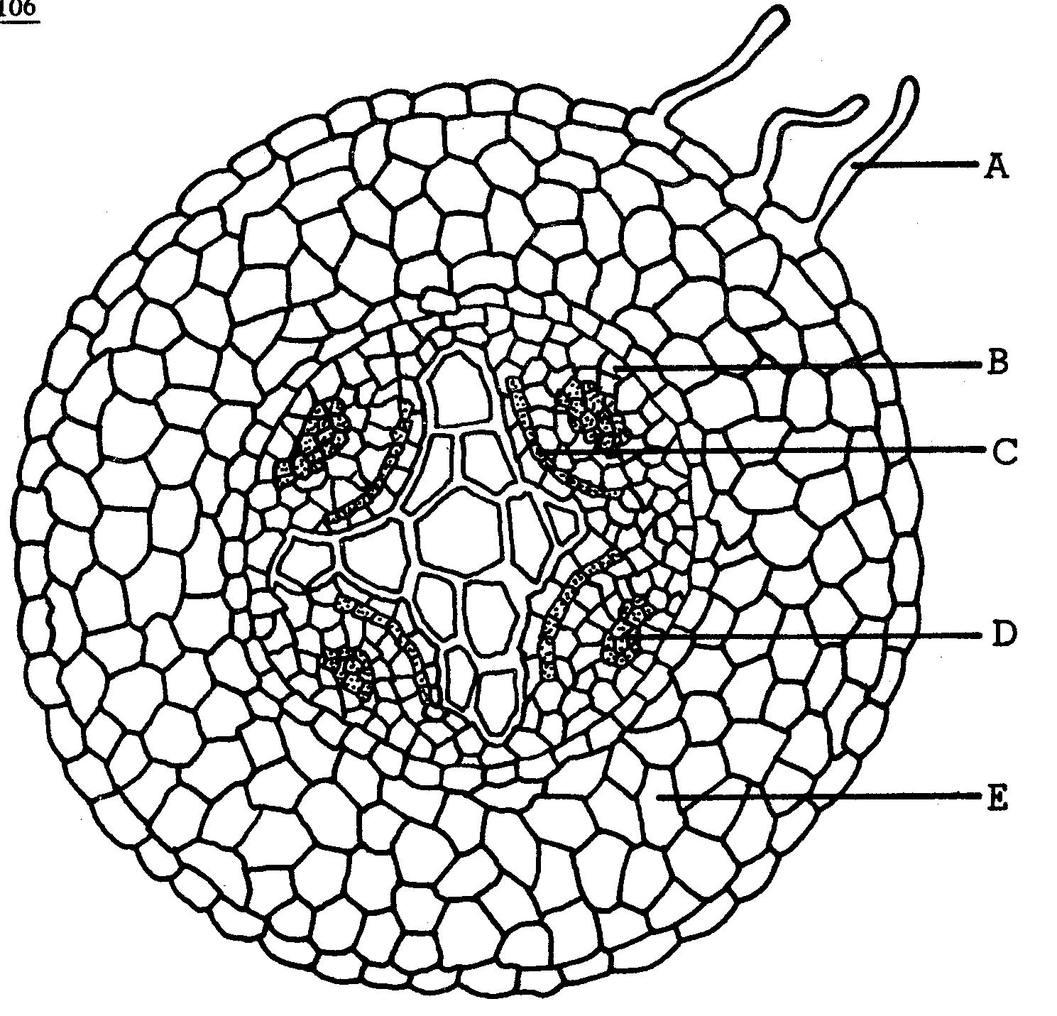
Questions 102-106

Cross Section of Young Dicot Root
Through The Region of Differentiation

- Serves as storage tissue for manufactured foods E

- Gives rise to secondary roots B

- Serves as an organ for the absorption of water and minerals A

- Serves primarily for the downward movement of soluble foods D

- Gives rise to secondary phloem and xylem C

Directions: Each group of questions below concerns an experimental situation. In each case, first study the description of the situation. Then choose the ONE best answer to each question following it and blacken the corresponding space on the answer sheet.

Questions 107-109
In order to spawn, salmon swim hundreds of miles upstream without food. Experiments have been conducted to clarify how this feat is accomplished. The following graph represents the results obtained in studying the effect of the water temperature on the energy expended by the salmon swimming at various speeds. Curves represent conditions ranging from rest (bottom curve) to top sustained speed (top curve).
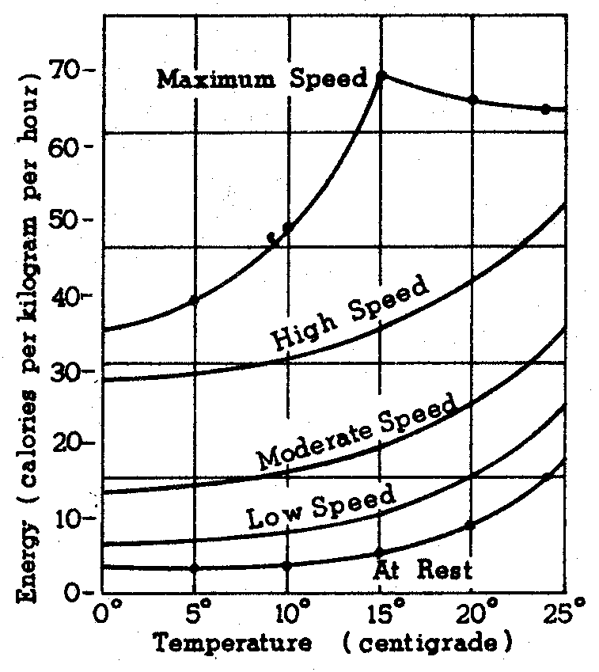

- A 2-kilogram salmon swimming at top speed at l5°C uses, in an hour, about
(A) 35 cal.
(B) 70 cal.
(C) 140 cal.
(D) as many calories as a 2-lb. salmon
(E) twice as many calories as a 4-kg. salmon

- Salmon resting at l00°C show an energy consumption
(A) more than that of fish swimming slowly at 5°C
(B) about the same as that of salmon swimming slowly at 10°C
(C) about one-third that of salmon swimming at top speed at l0°C
(D) about the same as that of salmon resting at 5°C
(E) about one-fifth that of salmon resting at 20°C

- The greatest change in energy consumption for each degree of temperature is shown by
(A) resting salmon between 15°C and 2SoC
(B) resting salmon between 5°C and 15°C
(C) fastest swimming salmon between 15°C and 25°C
(D) fastest swimming salmon between 5°C and l5°C
(E) none of the above

Questions 110-112
Analysis of digested cell nuclei yielded the fallowing set of data concerning the subunits of the DNA molecule.

Relative Amounts of Sugar and Phosphate in Samples of DNA

Purines Pyrimidines
Nuclei Adenine Guanine Cytosine Thymine
Beef liver 49.1 50.9 21.1 29.0
Human thymus 48.5 51.5 19.8 29.4
Human liver 49.9 50.1 19.9 30.3
Herring sperm 50.0 50.3 22.6 27.5
Yeast 49.2 51.0 17.4 32.6
T2 bacteriophage 49.7 50.4 16.7 32.6

Relative Amounts of Sugar and Phosphate In Samples of DNA

Nuclei Sugar Phosphate
Beef liver 49.1 50.9
Human thymus 48.5 51.5
Human liver 49.9 50.1
Herring sperm 50.0 50.3
Yeast 49.2 51.0
T2 bacteriophage 49.7 50.4

- One can infer from these data that
(A) the data reported for adenine, guanine,. cytosine, and thymine represent their relative percentages in the DNA of the cell
(B) the DNA was extracted from the cell nuclei with an ultracentrifuge
(C) the purine and pyrimidine contain nitrogen, but the sugar and phosphate do not
(D) inasmuch as the sums of the relative amounts of the molecular components are not always 100%, the data from this experiment are not valid
(E) the DNA of some of the cell nuclei is in the form of a single helix

- Which of the following conclusions CANNOT be drawn from the data?
(A) The amount of guanine is about equal to the amount of cytosine in human liver and thymus cells.
(B) The total amount of sugar and phosphate in the DNA molecule is approximately equal to the total amount of purines and pyrimidines.
(C) The amount of adenine is about the same as the amount of thymine in all of the cells studied.
(D) Guanine represents about one-fifth of the total purine and pyrimidine content of DNA.
(E) The highest amount of adenine is found in the nucleus of T2 bacteriophage.

- Which of the following statements is NOT justified by the data?
(A) The amounts of adenine and thymine in any of the nuclei are approximately equal.
(B) The relative amounts of sugar and phosphate are nearly constant regardless of the type of cell studied.
(C) The DNA of human thymus cells has approximately the same content of guanine and cytosine as the DNA of human liver cells.
(D) Adenine, thymine, cytosine, and guanine have different arrangements within the DNA molecule in yeast cells from that in T2 bacteriophage.
(E) The amount of guanine plus cytosine in T2 bacteriophage is about half the amount of the adenine plus thymine.

Questions 113-116
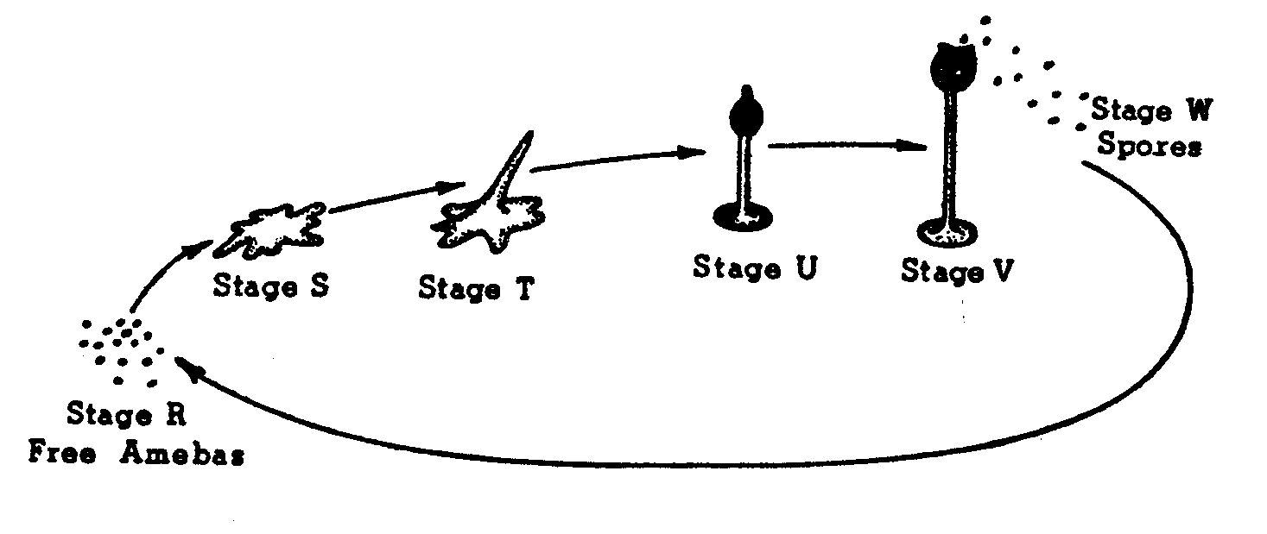

The diagram above shows the life cycle that is characteristic of a cellular slime mold. At stage R, free unicellular individuals much like amebas move about and feed. Under certain circumstances, the free amebas come together and form a “slug” (stages Sand T) that moves about and then settles in one place and changes to the characteristic form seen in stage U. At stage V, the fruiting body at the top of the slime mold bursts open and releases many spores. Later the spores develop into free-living individual amebas like those shown in stage R.

- If you wished to use the slime mold to study basic processes in development, you might consider the change from stage R to stage S as useful for analyzing
(A) fertilization
(B) meiosis
(C) mitosis
(D) growth
(E) tissue formation

- The individual cells at stage R are able to move and so is the “slug” at stage S. It is most probable that a major difference between cell movements in stage R and stage S result from difference in
(A) contractility
(B) coordination
(C) energy supply
(D) nuclear development
(E) heredity

- If you wished to compare the amount of hereditary material in individual cells in stage V and stage W by using a chemical method. you would probably measure
(A) carbohydrates
(B) fats
(C) amino acids
(D) proteins
(E) nucleic acids

- The process leading to change from stages S to U in the slime mold is most similar to which of the following processes in higher animals.
(A) Differentiation
(B) Metamorphosis
(C) Gastrulation
(D) Regeneration
(E) Degeneration

Questions 117-121
In a mating of a male Drosophila collected in nature with a normal female from a laboratory strain, 237 offspring were obtained. All of the offspring had normal eyes, except one unusual male, which had very narrow eyes. A series of matings is shown in the table below.

P₁ Unusual male x Normal female sisters
↓
68 males, normal eyes
73 females, slightly narrow eyes

F₁ Male. normal eyes (68) x female, slightly narrow eyes (73)
↓
¼ male, very narrow eyes
¼ male, normal eyes
¼ female, slightly narrow eyes
¼ female, normal eyes

- The most likely explanation for the appearance of the narrow-eyed male in the PI is the
(A) appearance of hidden variability
(B) occurrence of a mutation
(C) consequence of laboratory culture of larvae on artificial media
(D) result of hybridizing a wild fly with a laboratory fly
(E) culture of the offspring at a higher temperature than is usual in nature

- Assuming that a single locus causes the eye characteristic. the gene appears to function as
(A) a dominant allele
(B) a recessive allele
(C) an incompletely dominant allele
(D) a gene typical of that found in nature
(E) an allele of a multiple allelic series

- From the breeding data, it is clear that the gene is physically located on which chromosome?
(A) X chromosome
(B) Y chromosome
(C) Chromosome 2
(D) Chromosome 3
(E) Chromosome 4

- Why do the F_{l} males not show the genetic trait?
(A) The gene has variable penetrance.
(B) The effect of the gene is blocked by the Y chromosome.
(C) The allele is blocked by its dominant allele.
(D) The trait is expressed only in alternate generations.
(E) They do not contain the gene.

- A promising approach to ascertain if a female with very narrow eyes could be obtained would be to
(A) cross the normal F₂ males with the normal females
(B) cross the F₂ males that are not normal with the females that are not normal
(C) cross the F₂ very narrow-eyed males with normal females
(D) cross the F₂ slightly narrow-eyed females with normal males
(E) backcross the F₂ normal females with their male parents

Questions 122-125

The following experiment is designed to test the capacity of cell fractions from mouse liver to carry out oxidation of glucose and pyruvic acid.
The liver is first homogenized in a suitable medium and centrifuged to sediment nuclei. The supernatant liquid above the nuclear sediment is centrifuged again at a higher speed to sediment mitochondria. The supernatant above the mitochondrial sediment is the supernatant fraction referred to in the table. The latter fraction contains ribosomes. The separated fractions are then placed in an apparatus designed to measure changes in oxygen pressure.

Oxygen Consumption Expressed As Per Cent of Oxygen
Consumed By the Whole Homogenate

Glucose as Pyruvate as
Fractions Being Tested Substrate Substrate
1. Whole Homogenate 100 100
2. Nuclei 10 5
3. Supernatant 5 5
4. Mitochondria 3 75
5. Mitochondria + nuclei 5 50
6. Mitochondria + supernatant 150 130
7. Mitochondria + supernatant + nuclei 95 100

- The capacity to oxidize pyruvate resides largely in the
(A) supernatant fraction
(B) mitochondria
(C) nuclei
(D) microsomes
(E) supernatant fraction + nuclei

- From the data in the table, which of the following is an appropriate conclusion about nuclei?
(A) They have the same capacity to utilize pyruvate as do mitochondria.
(B) They contain DNA.
(C) They are unable to oxidize intermediates of the Krebs (oxidative) cycle.
(D) They lower the level of oxidation of pyruvate by mitochondria.
(E) They have no effect on the oxidation of glucose by mitochondria and the supernatant fraction.

- Which of the following is an appropriate conclusion about the supernatant fraction?
(A) It oxidizes glucose about as well as the homogenate.
(B) It oxidizes pyruvate more effectively than the homogenate when combined with mitochondria.
(C) It oxidizes pyruvate about as well as the homogenate.
(D) It oxidizes pyruvate as well as mitochondria.
(E) It converts glucose to pyruvate and enables mitochondria to oxidize the pyruvate.

- Assume that the supernatant fraction converts glucose to pyruvate and that mitochondria convert pyruvate to CO₂ and H₂O. What is the amount of ATP produced by mitochondria per mole of pyruvate relative to the amount of ATP produced by the supernatant per mole glucose?
(A) 1/2 as much
(B) The same
(C) 2 times as much
(D) 18 times as much
(E) 100 times as much

